PREDICT THE BURNED AREA OF FOREST FIRES WITH NEURAL NETWORKS

forestfires_norm<-as.data.frame(lapply(forestfires[,3:30],FUN=normalize))

> View(forestfires_norm)

> View(forestfires)

> summary(forestfires_norm)

FFMC DMC DC ISI temp

Min. :0.0000 Min. :0.0000 Min. :0.0000 Min. :0.0000 Min. :0.0000

1st Qu.:0.9226 1st Qu.:0.2326 1st Qu.:0.5040 1st Qu.:0.1159 1st Qu.:0.4277

Median :0.9406 Median :0.3694 Median :0.7697 Median :0.1497 Median :0.5498

Mean :0.9283 Mean :0.3783 Mean :0.6333 Mean :0.1608 Mean :0.5366

3rd Qu.:0.9574 3rd Qu.:0.4869 3rd Qu.:0.8280 3rd Qu.:0.1925 3rd Qu.:0.6624

Max. :1.0000 Max. :1.0000 Max. :1.0000 Max. :1.0000 Max. :1.0000

RH wind rain area dayfri

Min. :0.0000 Min. :0.0000 Min. :0.000000 Min. :0.0000000 Min. :0.0000

1st Qu.:0.2118 1st Qu.:0.2556 1st Qu.:0.000000 1st Qu.:0.0000000 1st Qu.:0.0000

Median :0.3176 Median :0.4000 Median :0.000000 Median :0.0004767 Median :0.0000

Mean :0.3446 Mean :0.4020 Mean :0.003385 Mean :0.0117774 Mean :0.1644

3rd Qu.:0.4471 3rd Qu.:0.5000 3rd Qu.:0.000000 3rd Qu.:0.0060229 3rd Qu.:0.0000

Max. :1.0000 Max. :1.0000 Max. :1.000000 Max. :1.0000000 Max. :1.0000

daymon daysat daysun daythu daytue

Min. :0.0000 Min. :0.0000 Min. :0.0000 Min. :0.000 Min. :0.0000

1st Qu.:0.0000 1st Qu.:0.0000 1st Qu.:0.0000 1st Qu.:0.000 1st Qu.:0.0000

Median :0.0000 Median :0.0000 Median :0.0000 Median :0.000 Median :0.0000

Mean :0.1431 Mean :0.1625 Mean :0.1838 Mean :0.118 Mean :0.1238

3rd Qu.:0.0000 3rd Qu.:0.0000 3rd Qu.:0.0000 3rd Qu.:0.000 3rd Qu.:0.0000

Max. :1.0000 Max. :1.0000 Max. :1.0000 Max. :1.000 Max. :1.0000

daywed monthapr monthaug monthdec monthfeb

Min. :0.0000 Min. :0.00000 Min. :0.0000 Min. :0.00000 Min. :0.00000

1st Qu.:0.0000 1st Qu.:0.00000 1st Qu.:0.0000 1st Qu.:0.00000 1st Qu.:0.00000

Median :0.0000 Median :0.00000 Median :0.0000 Median :0.00000 Median :0.00000

Mean :0.1044 Mean :0.01741 Mean :0.3559 Mean :0.01741 Mean :0.03868

3rd Qu.:0.0000 3rd Qu.:0.00000 3rd Qu.:1.0000 3rd Qu.:0.00000 3rd Qu.:0.00000

Max. :1.0000 Max. :1.00000 Max. :1.0000 Max. :1.00000 Max. :1.00000

monthjan monthjul monthjun monthmar monthmay

Min. :0.000000 Min. :0.0000 Min. :0.00000 Min. :0.0000 Min. :0.000000

1st Qu.:0.000000 1st Qu.:0.0000 1st Qu.:0.00000 1st Qu.:0.0000 1st Qu.:0.000000

Median :0.000000 Median :0.0000 Median :0.00000 Median :0.0000 Median :0.000000

Mean :0.003868 Mean :0.0619 Mean :0.03288 Mean :0.1044 Mean :0.003868

3rd Qu.:0.000000 3rd Qu.:0.0000 3rd Qu.:0.00000 3rd Qu.:0.0000 3rd Qu.:0.000000

Max. :1.000000 Max. :1.0000 Max. :1.00000 Max. :1.0000 Max. :1.000000

monthnov monthoct monthsep

Min. :0.000000 Min. :0.00000 Min. :0.0000

1st Qu.:0.000000 1st Qu.:0.00000 1st Qu.:0.0000

Median :0.000000 Median :0.00000 Median :0.0000

Mean :0.001934 Mean :0.02901 Mean :0.3327

3rd Qu.:0.000000 3rd Qu.:0.00000 3rd Qu.:1.0000

Max. :1.000000 Max. :1.00000 Max. :1.0000

> train <- forestfires_norm[1:258,]

> test <- forestfires_norm[259:517,]

> library(neuralnet) # regression

> library(nnet) # classification

> forestfires_model <- neuralnet(area~FFMC+DMC+DC+ISI+temp+RH+wind+rain+area+dayfri+daymon+daysat+daysun+daythu+daytue+daywed+monthapr+monthaug+monthdec+monthfeb+monthjan+monthjul+monthjun+monthmar+monthmay+monthnov+monthoct+monthsep,data = train)

> plot(forestfires_model)

> model_result <- compute(forestfires_model,test)

> str(model_result)

List of 2

$ neurons :List of 2

..$ : num [1:259, 1:29] 1 1 1 1 1 1 1 1 1 1 ...

.. ..- attr(*, "dimnames")=List of 2

.. .. ..$ : chr [1:259] "259" "260" "261" "262" ...

.. .. ..$ : chr [1:29] "" "FFMC" "DMC" "DC" ...

..$ : num [1:259, 1:2] 1 1 1 1 1 1 1 1 1 1 ...

.. ..- attr(*, "dimnames")=List of 2

.. .. ..$ : chr [1:259] "259" "260" "261" "262" ...

.. .. ..$ : NULL

$ net.result: num [1:259, 1] -0.01058 -0.00865 0.00629 0.00525 0.0075 ...

..- attr(*, "dimnames")=List of 2

.. ..$ : chr [1:259] "259" "260" "261" "262" ...

.. ..$ : NULL

predicted_area <- model_result$net.result

> cor(predicted_area,test$area)

[,1]

[1,] 0.7937952

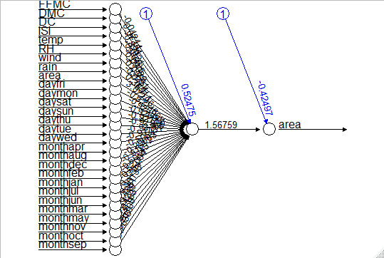

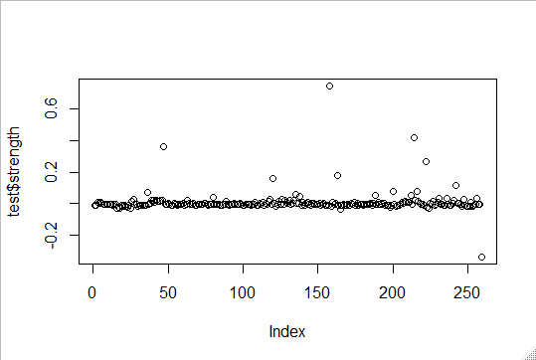

model_5<-neuralnet(area~FFMC+DMC+DC+ISI+temp+RH+wind+rain+area+dayfri+daymon+daysat+daysun+daythu+daytue+daywed+monthapr+monthaug+monthdec+monthfeb+monthjan+monthjul+monthjun+monthmar+monthmay+monthnov+monthoct+monthsep,data= forestfires_norm,hidden = 5)

> plot(model_5)

> model_5_res<-compute(model_5,test)

> pred_strn_5<-model_5_res$net.result

> cor(pred_strn_5,test$area)

[,1]

[1,] 0.9954365

